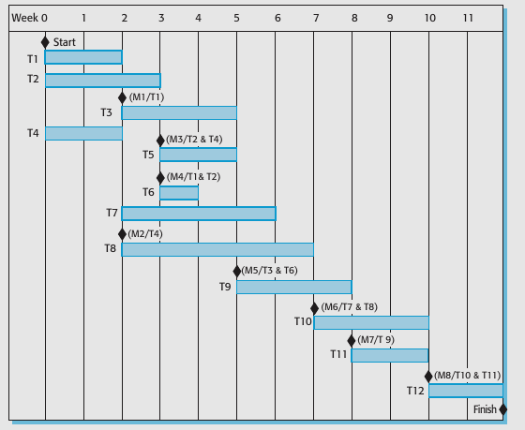

\

This chart is a Gantt chart, which is commonly used in project management to visualize the schedule of tasks over time. The horizontal axis represents time in weeks (from 0 to 11), and the vertical axis lists the tasks (T1 to T12).

### Tasks and Timeline

* **T1 and T2**: Both start at week 0.
* **T3**: Begins after T1 is completed.
* **T4**: Starts after both T1 and T2 are completed.
* **T5**: Can only start after T2 and T4 are done.
* **T6**: Starts after T2 and T4 are completed.
* **T7**: Begins after T4 is completed.
* **T8**: Starts after T4 is completed.
* **T9**: Begins after T6 is completed.
* **T10**: Starts after T7 and T8 are completed.
* **T11**: Begins after T9 is completed.
* **T12**: Starts after T10 and T11 are completed and marks the end of the project at week 11.

### Milestones

Milestones are significant points in the project timeline, marked by diamonds:

* **M1**: Occurs at week 3 after T3 is completed.
* **M2**: After T4 is completed.
* **M3**: After T2 and T4 are completed.
* **M4**: After T2 is completed.
* **M5**: After T6 is completed.
* **M6**: After T7 and T8 are completed.
* **M7**: After T9 is completed.
* **M8**: After T10 and T11 are completed, marking the project's finish.

### Dependencies

Brackets beside the milestones it indicate dependencies between tasks:

* For example, T5 cannot start until both T2 and T4 are completed.
* Similarly, T10 depends on the completion of both T7 and T8.

### Conclusion

This Gantt chart provides a clear visual representation of the project's schedule, showing when each task starts and finishes, and how tasks are interdependent. This is crucial for planning and tracking the progress of the project.

I’m sorry I couldn’t figure out how to create a power point with my voice in my system (I don’t use windows ) and the time couldn’t help me.